Inverse Functions
If two functions f(x) and g(x) are defined so that (f ο g)(x) = x and (g ο f)(x) = x we say that f(x) and g(x) are inverse functions of each other.

Description Of The Inverse Function:
Functions f(x) and g(x) are inverses of each other if the operations of f(x) reverse all the operations of g(x) in the reverse order and the operations of g(x) reverse all the operations of f(x) in the reverse order.

Example: The function g(x) = 2x + 1 is the inverse of f(x) = (x – 1)/2 since the operation of multiplying by 2 and adding 1 in g(x) reverses the operation of subtracting 1 and dividing by 2. Likewise, the f(x) operations of subtracting 1 and dividing by 2 reverse the g(x) operations of doubling and adding 1.

Example: Find a function g(x) that reverses the operations of f(x) = x³ – 1 that is also the inverse of f(x). Then, verify that f(x) and g(x) are inverses of each other by showing that (f ο g)(x) = x and (g ο f)(x) = x.

We need to reverse the operations of cubing and subtracting 1 in reverse order. So we start by adding 1. Then we take the cube root.

The function g(x) that corresponds to this is
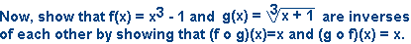

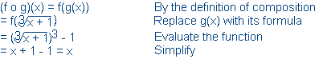

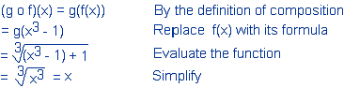

TIP: You should be able to plug in a value of x in one function and get a y-value. Then plug that y-value into the inverse function and you should get back your original value of x. If not, then you don’t have the correct inverse function.

Procedure For Finding The Inverse Function
To find the correct inverse function of f(x) every time, you can use this procedure:
- Replace f(x) with y.
- Switch each x with each y.
- Solve for y. The resulting function of x will be your inverse

Example: Use the previous procedure to find the inverse of the function f(x) = 3x – 5.
  - First, rewrite at y = 3x – 5.
  - Next switch x & y and rewrite as x = 3y – 5
  - Now solve for y.
x + 5 = 3y by the Addition Property of Equality.
(x + 5)/3 = y by the Division Property of Equality.
- Our inverse is g(x) = (x + 5)/3

Why does this procedure work?
ANSWER: The inverse of f(x) reverses the operations on x given by f(x) in reverse order. So you are actually doing the operations required to solve for x in f(x), getting x as a function of y. Since our inverse function is also a function of x, we need to switch variables.

Special Notation For The Inverse of f(x)
We designate the inverse of f(x) as f ^{–1}(x). Note that the ^{–1} exponent does not mean the negative one power when used to indicate the inverse!

Example: Find the inverse of h(x) = 2x³ – 1.
Using the procedure, we write as
y= 2x³ – 1
Switch x with y to get
x = 2y³ – 1
Now, solve for y
x + 1 = 2y³ Addition Property of Equality
(x + 1)/2 = y³ Division Property of Equality
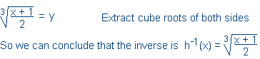

Note: In this case, since our original function was h(x) we used h⁻¹(x) as our notation rather than f⁻¹(x).

Graphs of Inverse Functions

When graphing f(x) and its inverse function f ⁻¹(x), the following will always be true:
- The graph of f ⁻¹(x) will always be a reflection of the graph of f(x) about the 45-degree angle line y=x.
- Solution points for f ⁻¹(x) may always be obtained by simply switching the x and y values of the solution points of f(x).

Example: Graph f(x) = x³ + 1, find its inverse, and then graph its inverse on the same graph. Show solution points for both functions.

To find the inverse of f(x), we start by writing this as y = x³ + 1. Then, switch x with y to get x = y³ + 1. Now, solve for y.

x – 1 = y³ Addition Property of Equality

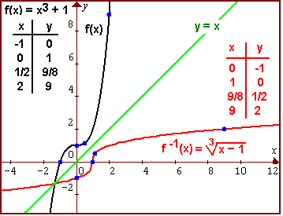

Note that all the points for f ⁻¹(x) are identical to those for f(x) except x is switched with y. Also note that the graphs are mirror images across the line y=x. Both of these properties are due to the fact that the inverse of f(x) is the same formula, rearranged in order to solve for the other variable, with x and y switched.

Functions That Don’t Have Inverses For Their Given Domain
If you try to find the inverse of the function f(x) = x², you go through the procedure to get
y = x²
x = y² Switch x with y
±√x = y Extract Square Roots
So f ⁻¹(x) = ±√x is your inverse function?

WRONG! f ⁻¹(x) = ±√x is NOT a function!
This will always happen when f(x) is not one-to-one. In other words, this will happen when f(x) is a function with graph that does not pass the horizontal line test. If it does not pass the horizontal line test, then it will have two x-values corresponding to the same y-value. If we try to “reverse” the operations and recover an x-value that produces a y-value, which is what an inverse function does, we get two answers.

Here are the graphs of f(x) = x² and its inverse “equation”. Sure, enough, the graph of the inverse equation is a mirror image across the line y=x but this inverse “equation” does not pass the vertical line test and so is not a function of x.

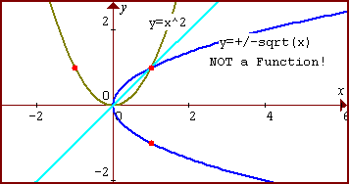

Ways To Determine If a Function f(x) Does Have an Inverse For a Given Domain
- Try to solve for the independent variable. If you can not solve without using a +/- sign, then the function is not one-to-one and will not have an inverse for its entire domain. For example, if we solve y = x² + 1 for x, we get x = ±√(y-1), and this would mean that two different x-values produce a given y value like y=5 .
- Use the Horizontal Line Test on the graph of the function to determine if it is one-to-one. If any horizontal line passes through the graph in 2 or more points, then the function is not one-to-one and will not have an inverse for all of its domain.

Fixing Functions That Are Not 1-to-1 By Restricting Their Domain
If you restrict the domain of the function f(x) = x² to x ≥ 0 and try to find the inverse using the procedure, you get

y = x² where x ≥ 0
x = y² Switch x with y
√x = y Extract Square Roots
This time, there is no ± however because y must be positive. This is because the y-value takes on all the values of x before we switched variables, and x was restricted to
x ≥ 0.

So f ⁻¹(x) = √x is the inverse function. The graphs of f(x) = x² , x ≥ 0 and f ⁻¹(x) = √x are shown on the next page. By restricting the domain of y=x², our graph is only the right side of the parabola, passing the horizontal line test. The inverse graph, a reflection about the line y=x, is a function since it now passes the vertical line test.

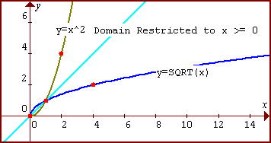

Example: Restrict the domain of f(x) = (x – 1)² so that it has an inverse. Then, find its inverse and plot both graphs on the same coordinate axis.

The easiest way to find out how to restrict this domain is to plot its graph. Using the horizontal shift rule, we see that f(x) = (x-1)² is a shift of y=x² right 1 unit with graph shown below.

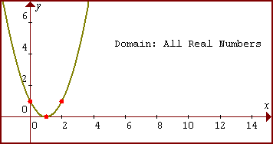

If we eliminate the left side of the parabolic curve, we will have a 1-to-1 function that passes this horizontal line test. This is achieved by restricting our domain to x ≥ 1. Our new graph is:

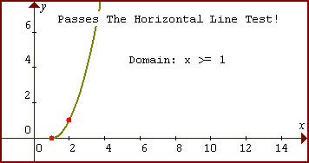

Now, find the inverse of f(x) = (x – 1)² using the procedure.

f(x) = (x – 1)² where x ≥ 1
y = (x – 1)² where x ≥ 1
x = (y – 1)² Switch x with y
√x = y - 1 Extract Square Roots
√x + 1 = y Addition Property of Equality

There is no ± however because (y – 1) must be ≥ 0. This is because the y-value takes on all the values of x before we switched variables, and x was restricted to x ≥ 1 which means (x – 1) ≥ 0.

So f ⁻¹(x) = √x + 1.
To easily graph both of these, we plot a few solution points for f(x) and then switch x with y to obtain points for f ⁻¹(x) as shown below.

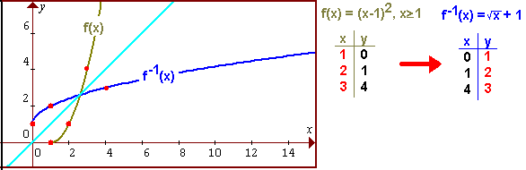

The Domain and Range of a Function and its Inverse
As may be seen in the previous example, we obtain points for the inverse by simply switching x with y in each solution point of the original function. Thus we can say:

The domain of f ⁻¹(x) will take on the same values as the range of f (x) and
The range of f ⁻¹(x) will take on the same values as the domain of f (x).

Example: In the previous problem, where we graphed f(x) = (x-1)², x ≥ 1, and its inverse f ⁻¹(x) = √x + 1, what are the domain and range of f(x) and f ⁻¹(x)?

The domain of f(x) was restricted to x ≥ 1 or [1, ∞).
The range of f(x) is y ≥ 0, or [0, ∞). as seen at the graph, since y = 0 is the lowest value and there is no highest possible value of y.

Switching domain with range, and range with domain results in
The domain of f ^{–1}(x) will be x ≥ 0, or [0, ∞).
The range of f ^{–1}(x) will be y ≥ 1, or [1, ∞).

The graphs of these two functions verifies these results.

